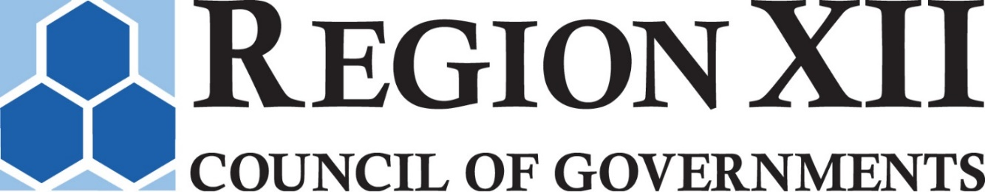

June 30, 2022

TO: Policy Council Members
FROM: Richard T. Hunsaker, Executive Director
RE: July Policy Council meeting

DINNER MEETING JULY 7, 2022

The next meeting of the Region XII COG Policy Council will be on Thursday, July 7, 2022 at 6:00 PM in the Training Room at Region XII COG. I have enclosed minutes from the last meeting and a proxy form. If you wish to appoint a proxy, please email the proxy form as soon as possible prior to the meeting and give your materials to the person. Also enclosed are documents related to action items. The Policy Council meeting will follow the Executive Board meeting. Please contact me if you have any questions about this information (712-775-7800 or rhunsaker@region12cog.org).

REGION XII COG POLICY COUNCIL AGENDA
TRAINING ROOM, REGION XII COG, CARROLL IA
July 7, 2022 - 6:00 p.m.

- Roll Call/Call to Order
II. Introductions
- Minutes of the April 7, 2022 Meeting
- Disclosures of Any Conflicts of Interest
V. Old Business
VI. New Business
- Consider Personnel Policy Revision
- Consider Procurement Policy Revision
- Consider Adoption of the 2023 Comprehensive Economic Development Strategy (CEDS)
- Public Hearings (6:30 PM)
- Proposed Amendment to the FY2022-2025 Transportation Improvement Program
- Proposed Adoption of the FY2023-2026 Transportation Improvement Program
- Consider Approval of Proposed Amendment to the FY2022-2025 Transportation Improvement Program
- Consider Resolution Adopting the FY2023-2026 Transportation Improvement Program
- Executive Director’s Report
- Fiscal Report
- Local Assistance Report
- Transit Report
- Other
VII. Adjourn

Region XII COG board meetings are open to all individuals regardless of disability. Any person with a disability requiring a reasonable accommodation to participate in a board meeting should contact the COG at 712-792-9914 at least two business days prior to the meeting. This institution is an equal opportunity provider and employer.

